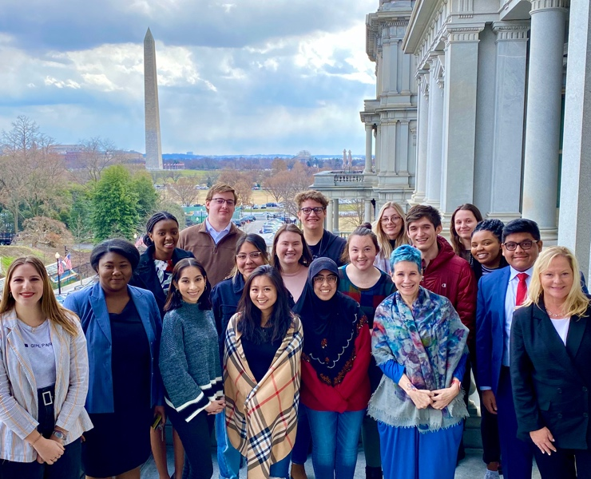
The Political Science Department, in partnership with the Walter Center for Career Achievement and PACE, presents
IU POLS DC
Indiana University Internship in
Politics, Opportunity, Leadership, Social Entrepreneurship
We are recruiting for both Fall 2021 and Spring 2022
Our internship program provides fulltime IU student status, housing, coursework, networking opportunities in DC.

Call-outs for FALL 2021 Internships – deadline for Applications extended to February 26, 2021
Call-outs for Spring 2021 Internships – deadline for Applications March 12, 2021

- Wednesday, February 17, 4 pm -- Zoom Meeting ID: 834 2938 3384
- Thursday, February 18, 4 pm -- Zoom Meeting ID: 834 2938 3384
- Wednesday, February 24, 12 noon -- Zoom Meeting ID: 834 2938 3384
- Thursday, February 25, 4 pm -- Zoom Meeting ID: 834 2938 3384
- Monday, March 1, 2 pm -- Zoom Meeting ID: 834 2938 3384
- Wednesday, March 3, 10am -- Zoom Meeting ID: 834 2938 3384

All Info Sessions are on Zoom https://iu.zoom.us/j/83429383384
PROGRAM AT A GLANCE
- Semester prior to internship: take X299, a Political Science/ Walter Center class on Career Preparation. Focus in on Resume Writing, Writing Applications and Cover Letters, Interviewing Skills, Networking and Professional Etiquette. In the class we will work with you to find an internship with the help of Walter Center Career coaches and Political Science alumni networks.

- Semester of Internship: Enjoy your internship in DC. Enroll as a fulltime student in two 300-level classes taught by IU faculty in DC and six credits of POLS-X477 internship. You will be charged a $4500 housing fee on your bursar bill for double occupancy room in a historic Washington town house a two blocks from Capitol Hill. Have a great time, learn new skills and return with the proficiency and contacts to find a fabulous job.
Questions? Ask Professor Christine Barbour barbour@indiana.edu or see https://polisci.indiana.edu/career-preparation/internships/iu-pols-dc.html

